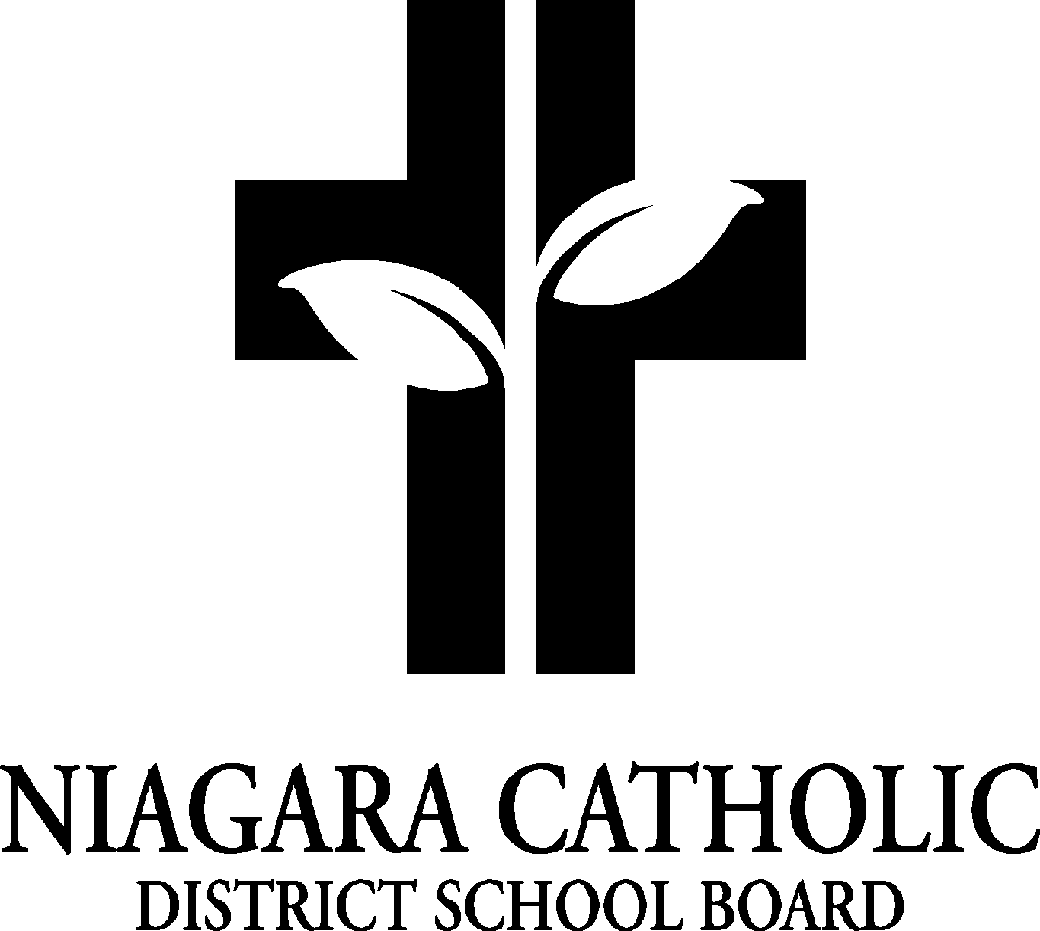

St. Alexander Catholic School Council

AGENDA

Wednesday, March 26, 2024 - 5:30pm

1. Prayer - Mrs. Pozzobon

2. Role Call

Present:  Kristin DeDivitiis, Sarah Musso, Jade Jones, Victoria Jaski, Becky Dufton, Teide Zimmerman, Ashley Barron, Juli Della Ventura, Andrea Pollecilla, Alycia Tallman, Alejandia Sparow, Mr. Venzon, Mrs. Pozzobon and Miss Principi, Mrs. Sutherland

Absent:

3. Chair Report

- Fundraising -Big Box Cards - April/May

Start on April 2nd

Will there be a change in design?

There will be both birthday and celebrations cards (2 different boxes)

- Purse Bingo - May 23 2024 at Amici’s

* Review the requirements of the Permit
* Sell bingo dabbers? Or use and collect?
* Business Letters
* Vendor Tables?
* Purchase of purses
* Make poster and print tickets
* Business interested can sponsor--donate $, purse, etc.

4. Principal’s Report

*The following Governance Policies are currently being reviewed as part of the* [*Establishment and Cyclical Review of Policies Policy (100.5)*](https://docushare.ncdsb.com/dsweb/Get/Document-1982025/100.5%20-%20Establishment%20and%20Cyclical%20Review%20of%20Policies%20Policy.pdf) *review process.*

*To be considered, all submissions must identify the specific Governance Policy and include your name, phone number, address and affiliation with Niagara Catholic.*

*Anonymous or pseudonymous submissions will not be considered*

· [*Advocacy Expenditures Policy 100.9*](https://cdn.niagaracatholic.ca/wp-content/uploads/2024/02/Advocacy-Expenditures-Policy-100.9.pdf)

· [*Elementary Standardized Dress Code Policy 302.6.10*](https://cdn.niagaracatholic.ca/wp-content/uploads/2024/02/Elementary-Standardized-Dress-Code-Policy-302.6.10.pdf)

*Please submit your feedback to* [*Anna Pisano*](https://niagaracatholic.ca/contact-anna-pisano/) *by 12:00 p.m. March 27, 2024*

· [*Employee Workplace Harassment Policy 201.7*](https://cdn.niagaracatholic.ca/wp-content/uploads/2024/03/Employee-Workplace-Harassment-Policy-201.7.pdf)

· [*Employee Workplace Violence Policy 201.11*](https://cdn.niagaracatholic.ca/wp-content/uploads/2024/03/Employee-Workplace-Violence-Policy-201.11.pdf)

· [*Occupational Health and Safety Policy 201.6*](https://cdn.niagaracatholic.ca/wp-content/uploads/2024/03/Occupational-Health-and-Safety-Policy-201.6.pdf)

· [*Purchasing Supply Chain Management Policy 600.1*](https://cdn.niagaracatholic.ca/wp-content/uploads/2024/03/Purchasing-Supply-Chain-Management-Policy-600.1-1.pdf)

*Please submit your feedback to* [*Anna Pisano*](https://niagaracatholic.ca/contact-anna-pisano/) *by 12:00 p.m. May 1, 2024*

i.Lenten Food Drive

Pelham Cares will pick up food drive food tomorrow

Student Council has prepared the pick up

ii.Holy Week and Holy Thursday Last Supper Celebration

iii.End of Year Trips

iv.End of Year BBQ - Knights of Columbus volunteers to assist with getting everything ready

* June 18th 4pm to 5:30pm
* Ice Cream Truck

v.Classroom Organization for 2024-25

* In the process of how many classes we will have next year
* Have at least 2 additional portables
* Currently new registrations need to be Catholic and Inbounds

vi.Notre Dame Outfitters Uniform Fittings - Grade 8’s

vii.Easter School Mass - April 3rd

* @10 am

viii.Chess Team to Tourney - April 16

* St. Mary’s School with Mr. Inman

ix.Badminton Tourney - April 18

* With Mr. Brisson

x.Student Leadership Symposium April 30

* Student Senate for 2024 2025 will be voted by students next week
* Students will be traveling to the Symposium with Mrs. Roech

xi.First Reconciliation Friday, April 26 and May 3

* During the school day at the church

xii.First Holy Communion Sunday,

* April 28 Principi/Thomas
* May 5 Princip/Bellantino

xiii.Grade 8 Confirmation May 9th - 7pm

5. School Improvement / Staff Report - Miss Principi

* Short learning cycles and data collection

6. Treasurer’s Report

NEXT MEETING:

May 28, 2024 at 5:30pm